BEI Model Options – Model 2023
Alongside the update to the BEI TestStand 2023 Model and Template, the SW Control Tools 2023 were also updated to include a GUI used to update and modify common BEImodelOption variables.

SW Control Tools 2023 – BEI Set Model Options GUI
The GUI is found under “Tools” -> “>BEI Set Model Options”.
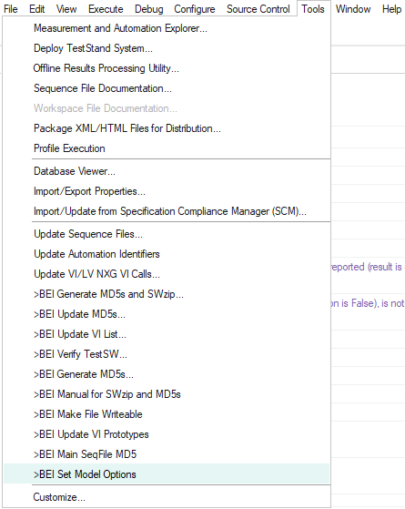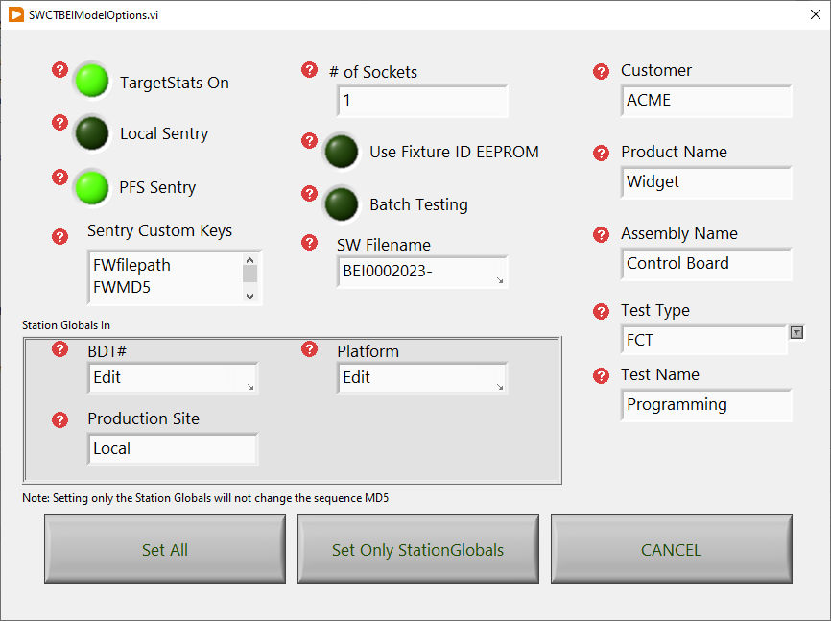
Listed below are descriptions of the variables that can be updated using the Set Model Options GUI:

Model Options:
- TargetStats On – When turned ON, test results are logged to the TargetStats database. Admin logins will have the option to turn the TargetStats Database OFF via pop-ups at Runtime. Default value is True (ON).
- Local Sentry – When turned ON, Data is pulled from Local Sentry and not PFS Sentry. Default value is False (OFF).
- PFS Sentry – When turned ON, Data is pulled from PFS Sentry, not Local Sentry. Admin logins will have the option to select between PFS Sentry and Local Sentry via pop-ups at Runtime. Default value is True (ON).
- Sentry Custom Keys – Specify custom Sentry Key Names for Data to be pulled from Sentry (whether Local Sentry or PFS Sentry). Use a carriage return to separate entries, if multiple Custom Keys are required. If no Custom Keys are required, set value to blank. Some examples of Custom Sentry Keys include FWfilepath, FWMD5, FWresponse.
- # of Sockets – Set to the number of UUTs to be tested at a time. Default value is 1.
- Use Fixture ID EEPROM – When turned ON, the test system will read the EEPROM on the removeable fixture. When turned OFF, the test system will run as though there is no removeable fixture or no EEPROM present. Default value is False (OFF).
- Batch Testing – When turned ON, the Batch model will be used when testing multiple UUTs at once. When turned OFF and the Number of Sockets is more than 1, the Parallel model will be used when testing multiple UUTs at once. When turned OFF and the Number of Sockets is 1, the Sequential Process Model will be used when testing a single UUT at a time. Default value is False (OFF).
- SW Filename – Set this value to the complete file name (including the revision) of the Test Software. The value stored here must match the actual Test Software Filename when an Operator login executes a test. Default value is “BEI0002023a-Template_V1_0.seq”.

TargetStats Filter Settings:
- Customer Name – Set to the Customer’s Company Name. This value will be displayed in the Model GUI, Test Report, and TargetStats. New customers will need to be added to TargetStats. If the customer’s name is not added to the TargetStats Database, the generated XML files will be quarantined and not uploaded to the database.
- Product Name – Set to the final product name or system.
- Assembly Name – Set to the name of the board or assembly system that is being tested.
- Test Type – Select the test type from the provided dropdown list. If the Test Type is not a standard value, test results will fail to be sent to the TargetStats database. Standard Test Types include: AOI, ESS, FCT, FP, HALT, HASS, HIPOT, HMU, ICT, JTAG, OTHER, and Safety.
- Test Name – Can be used to distinguish between two tests with the same Test Type that are being run on the same assembly. Examples include: (BLFT vs. Software Load) and (Pre-HASS vs. Post-HASS). If no differentiation is needed, set value to blank.

StationGlobal Options:
- BDT Number – Set to the BDT # of the tester. This should be the BDT # of the Target Tester Base, Edge Tester, or custom tester, and not the BDT # for a removeable fixture. Default value is “Edit StationGlobals.BEI.Info.TesterPN”.
- Platform – Set to the Tester Platform Type. Common Platform Types include: Target Tester, Edge Tester, Step One Tester, and Custom Tester. Default value is “Edit StationGlobals.BEI.Info.Platform”.
- Production Site – Set to the current production site. Update this value if the Tester is moved. Examples of Production Sites include, but are not limited to: Winona, Rochester, Guadalajara, Tijuana, etc.

TestStand 2023 Model – BEImodelOptions Sequence Callback
The BEImodelOptions callback can still be used as a sequence callback in the test sequence, if the developer wishes to have different settings than what is controlled by the GUI or set to the default value.
Listed below are descriptions of the steps located within the BEImodelOptions callback:

Rarely Used/Changed Model Options:
- GetSNfromUUT – When GetSNfromUUT is TRUE, user will not be able to enter a UUT SN and you must add project code to a GetSNandWO callback to obtain the SN from the UUT. Default value is FALSE.
- Sentry.EveryUUT – When EveryUUT is TRUE, Sentry criteria is obtained in PreUUT for every UUT. When it is FALSE, Sentry criteria is obtained only when workorder or PFSgate changes. This setting is applicable only when Sentry is enabled. Default value is FALSE.
- Parallel.HideExecutions – When TRUE, the execution of the test is hidden. Default value is FALSE.
- Use seq batch mode – In order for Batch sync to execute correctly, this value must be set to FALSE. When set to TRUE, the execution speed is improved. Default value is TRUE.
- RuntimeFileControl.EveryUUT – When TRUE, RunTimeFileControl (RTFC) runs on every UUT. When FALSE, it runs only when the test seq is first started. This setting is applicable only when RTFC is enabled. Default value is FALSE.
- RuntimeFileControl.keepFilesReadOnly – When TRUE, RTFC will keep all files set to read only. This setting is applicable only when RTFC is enabled. Default value is FALSE.
- requirePFSforOperators – When requirePFSforOperators is TRUE and user is an operator, PFS is turned ON in the 'Configure Execution' sequence. Default value is TRUE.
- requireTargetStats2forOperators – When RequireTargetStatsForOperators is TRUE and the user is an operator, datalogging is turned on in the 'Configure Execution' sequence. Default value is TRUE.
- RuntimeFileControl – When TRUE, RTFC is ON and the MD5 of files is checked. RTFC does several things to help ensure that files used are not invalid or changed. Default value is TRUE (ON).
- RuntimeFileControl.On, if operator – Step runs only when the user login is an operator account to set RTFC to ON automatically. Default value is TRUE.
- Set Fixture HW Info – This step sets the Fixture Hardware Part Number and Revision to blanks. If these are left blank, then the values will not be reported in the Test Report Header. If an EEPROM is used (as set by the Set Model Options GUI), these values will be updated with the read value during the step “Get Fixture ID from EEPROM”.
- Set assembly number – Typically, not used. Leave blank and it will not show up in the test report. You may want to set the assembly number in PreUUT with a response from ModelSupport\db.llb\WorkorderAssemblyNum.vi. Default values are blank.
- Set TesterID to PC Name – This step retrieves the Test System’s computer name to be reported in the Test Report Header. The PC Name must also match the TestHardwareConfig value from Sentry (whether Local Sentry or PFS Sentry).
- Set TestDescription – This value is set based partially on values input from the Set Model Options GUI. The created Test Description is displayed in the Model GUI and in the Test Report Header. The test description is made up of the following values: <Customer Name> <Product Name> <Assembly Name> <Test Type>.

Steps Controlled by the SW Control Tools GUI:
- Parallel.NumberSockets – This value is set based on the input from the Set Model Options GUI. Set to the number of UUTs to be tested at a time.
  - Parallel.DoNotUseSocket() – This step automatically sets the boolean variable based on the # of sockets specified in the Set Model Options GUI. When the number of sockets is greater than 1, the variable is set to TRUE (like when running in 'mulit-UUT' parallel or batch systems) and the first socket index will be 1. When the number of sockets is 1, the variable is set to FALSE (like when testing one UUT at a time) and the first socket index will be 0.
- Parallel.Batch – This value is set based on the input from the Set Model Options GUI. When turned ON, the Batch model will be used when testing multiple UUTs at once. When turned OFF and the Number of Sockets is more than 1, the Parallel model will be used when testing multiple UUTs at once. When turned OFF and the Number of Sockets is 1, the Sequential Process Model will be used when testing a single UUT at a time.
- TargetStats2On – This value is set based on the input from the Set Model Options GUI. When turned ON, test results are logged to the TargetStats database. Admin logins will have the option to turn the TargetStats Database OFF via pop-ups at Runtime.
- Sentry.On – This value is set based on the input from the Set Model Options GUI. When turned ON, Data is pulled from PFS Sentry, not Local Sentry. Admin logins will have the option to select between PFS Sentry and Local Sentry via pop-ups at Runtime.
- Sentry.Local – This value is set based on the input from the Set Model Options GUI. When turned ON, Data is pulled from Local Sentry and not PFS Sentry.
- Create Custom Sentry Key Array – This value is set based on the input from the Set Model Options GUI. This step runs a VI that separates each Custom Sentry Key entered in to the Set Model Options GUI and outputs an array with each individual key indexed for use during the test execution.
- Set official main filename – This value is set based on the input from the Set Model Options GUI. Set this value to the complete file name (including the revision) of the Test Software. The value stored here must match the actual Test Software Filename when an Operator login executes a test.
- Set Customer – This value is set based on the input from the Set Model Options GUI. Set to the Customer’s Company Name.
- Use Fixture ID EEPROM? – This value is set based on the input from the Set Model Options GUI. When turned ON, the test system will read the EEPROM on the removeable fixture. When turned OFF, the test system will run as though there is no removeable fixture or no EEPROM present.
  - Get Fixture ID from EEPROM – This step runs a VI that reads the EEPROM from the removeable fixture. If there is no EEPROM used (as set by the Set Model Options GUI), this step is skipped.
  - Fixture ID Error – This step only runs if there is an error when attempting to read the EEPROM of the removeable fixture. A popup will indicate if the EEPROM could not be read. If there is no EEPROM used (as set by the Set Model Options GUI), this step is skipped.
- Set product name – This value is set based on the input from the Set Model Options GUI. Set the product name variable.
- Set production Site – This value is set based on the input from the Set Model Options GUI. Set the production site variable. Update this value if the Tester is moved. Examples of Production Sites include, but are not limited to: Winona, Rochester, Guadalajara, Tijuana, etc.
- Set AssemblyName – This value is set based on the input from the Set Model Options GUI. Set Assembly Name variable.
- Set Test Type – This value is set based on the input from the Set Model Options GUI. Set the Test Type variable. Standard Test Types include: AOI, ESS, FCT, FP, HALT, HASS, HIPOT, HMU, ICT, JTAG, OTHER, and Safety.
- Set TestName – This value is set based on the input from the Set Model Options GUI. Set the test name variable, if applicable.
- Set Station Info – This value is set based on the input from the Set Model Options GUI. Set the TesterPN StationGlobal variable. This should be the BDT # of the Target Tester Base, Edge Tester, or custom tester, and not the BDT # for a removeable fixture.

Steps Controlled by StationGlobals:
- Set Non-Benchmark Site Variables – This step only runs if StationGlobals.BEI.Features.NON_BEI_SITE is set to TRUE. The step automatically disables PFS and enables LocalSentry, RTFC, and TargetStats2. If the NON_BEI_SITE StationGlobal is set to FALSE, this step is skipped. The default value for the NON_BEI_SITE StationGlobal variable is FALSE.
- Set Debug Mode Variables – This step will only run if the StationGlobals.BEI.Features.Debug_Mode is set to TRUE. The step automatically disables PFS, RTFC, and TargetStats2. If the Debug_Mode StationGlobal variable is set to FALSE, this step is skipped. If the user is an operator, the Debug_Mode StationGlobal variable is set to FALSE at the beginning of the BEImodelOptions callback. The default value for the Debug_Mode StationGlobal variable is TRUE.

Sentry Model Settings
Local Sentry settings can be found under Stationglobals.localSentryData.<Test Sequence Name>.<PFS Gate>
- The local sentry StationGlobal will not appear until the test sequence is run one time.
- PFS Sentry settings are pulled from a work order in PFS.
- If Sentry is set ON and Local Sentry is set OFF, an administrator user login will get a popup to use Local Sentry instead of PFS Sentry, which is faster than updating a work order during debug.

Sentry Tooling
The Tooling should be set to the name of the computer in the tester base and also list fixtures that can be used on the base
- Ex: TestHardwareConfig= tst-c-bei-t0123: BDT0000456, BDT0000789
- This example indicates that the base PC must be named tst-c-bei-t0123 and the two fixtures that can be used on it are -0456 and -0789. If the equipment being used does not match the test will not run. If you don’t have any removable fixtures simply don’t list any.

Sentry Programs
The Programs, by default, include the items below:
ReportPath= C:\Testdata\Customer\Product
TestSWfilepath= C:\BEIstdModel_2023a\BEI0002023a-Template_V1_0.seq
TestSWMD5= tbd
FWfilepath= I:\TestSoftware\Utilities\winMd5Sum.exe
FWMD5= a869749de98e20880c525dab5b8dea7c
FWresponse= 111
- ReportPath – Enter the location to save test reports.
- TestSWfilepath – Enter the path of the test file being used, filled in by default when created.
- TestSWMD5 – MD5 of the test software is stored under this key in Local Sentry automatically whenever the file is zipped. This value must be copied to a work order when running with PFS Sentry.
- UUTFWfilepath – Path of firmware file, if applicable. This Sentry key can be deleted if no UUT Firmware programming is required for the test.
- UUTFWMD5 – MD5 of firmware file, if applicable. This Sentry Key can be deleted if no UUT Firmware programming is required for the test.
- UUTFWresponse – Expected response of SW rev request to the UUT, if applicable. This Sentry Key can be deleted if the UUT SW revision is not needed or will never change.
Note: Other custom entries can be created.
- The 2023 Template seq includes a “Get Custom Sentry Items” sub sequences that should be used to get info from sentry. It is already setup to work correctly with PFS Sentry or Local Sentry.

PFS.ini File Settings
The PFS.ini file is located in the ModelSupport folder and allows you to customize options for PFS. Typically, there is no need to modify this file but listed below are some details on the options.
- GatewayServer – The GatewayServer parameter indicates which PFS server the test results should be sent to. Each database has its own specific Database Alias and Gateway. These values are stored in the PFS.ini file to allow for updates, as needed (for example, if a tester is moved from one site to another). Refer to the “TestLink Database Names and Server Aliases” document on the BEI Sharepoint site for Database Alias and Gateway values.
- Database – The Database parameter indicates which PFS server the test results should be sent to. Each database has its own specific Database Alias and Gateway. These values are stored in the PFS.ini file to allow for updates, as needed (for example, if a tester is moved from one site to another). Refer to the “TestLink Database Names and Server Aliases” document on the BEI Sharepoint site for Database Alias and Gateway values.
- Operation_Codes – This is set to the PFS gate that the test will be run under, typically during development of the tester this is left as is and once production creates real work orders, they may change to name of the test step in PFS. At that time, the STE can update the ini file as needed. You can add multiple test gates i.e. T_FCT1, T_FCT2 and the operator will have to select which one they are running when they connect to PFS. This may be done if you are running two or more PFS test gates with one set of software (i.e. testing a PCB before and after a burn in step you would use the same software, but it would be a different test gate in PFS).
- Work_Center – Work centers vary from site to site, though they generally refer to either the physical location of the client or a logical grouping of equipment that the client is included in. If there is no Work Center specified, TestLink will attempt to retrieve the correct work center from PFS based on the other information provided. If TestLink is not able to find the work center with the provided data, the procedure call will fail and alert the operator. The default value is blank and is typically left as is.
- Timeout_ms – The amount of time allotted for PFS to respond to a request made. The default value is 25000 and is typically left as is.
- DefaultFailCode – The default fail code returned if communication is unsuccessful. The default value is 1 and is typically left as is.
- Use_Cached_Info – Sentry information is pulled from PFS and cached by default to prevent extra traffic on the network. This is a problem when debugging or executing validation using PFS Sentry, since changes you make in PFS are not reflected immediately. In these cases, you should set this variable to FALSE so there is no delay. Once debug is complete, it should be changed back to TRUE.
- ShowTransactionWindow – Controls if the transaction window is shown as the active window while communicating with the PFS server. The default value is TRUE and is typically left as is.
- Override_OK – When using PFS, if a serial number has already been tested and passed at a test station, it will not let you test it again unless you go into PFS and override the serial number back to test. For debug or validation, when running the same serial number multiple times this can be time consuming. If you set this variable to TRUE, it will automatically override the serial number scanned back to the test. When done, this should be set back to FALSE.
- Port – The specified port that the TestLink Client will use to initiate a connection to PFS using TLS. The default Port value is 500000 and is typically left as is.

TestLinkRootCA Certificate Set-Up
Located within the PFS.ini file are instructions on where to find the updated TestLinkRootCA.cer certificate required to send encrypted data to PFS. The certificate will need to be loaded and installed on each Tester PC running the 2023 TestStand Model and logging test data to PFS.
The certificate can be found at: \\mn-s10\engineering_software\FTD_software\TestLink Certificate\
To install the certificate:
- Save the certificate locally on the tester PC.
- Open the certificate. In the "General" tab, select "Install Certificate".
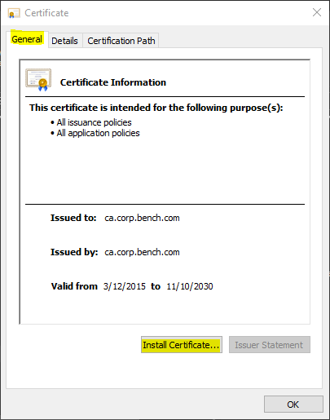
- Using the Install Wizard, select to add the certificate to the "Local Machine". Click "Next".
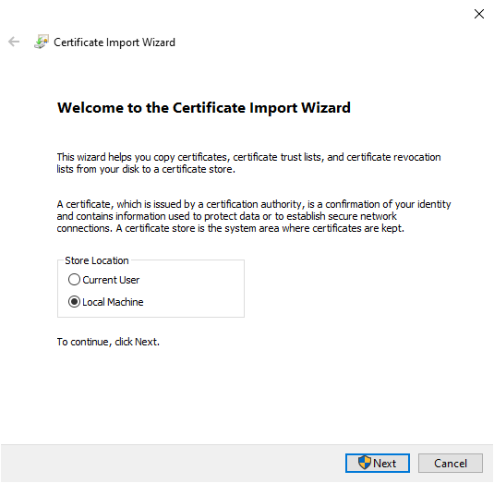
- Select to manually place the certificate (Checkbox next to "Place all certificates in the following store"). Select "Browse".
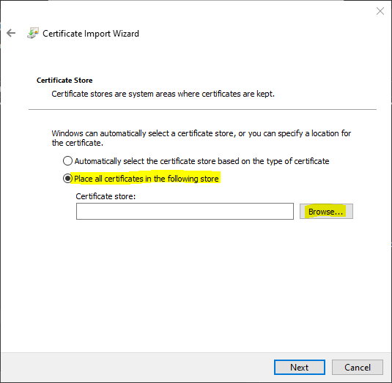
- Click the checkbox next to "Show Physical Stores" in the next window popup.
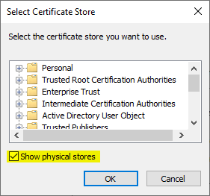
- Click the "+" next to "Trusted Root Certification Authorities" and highlight “Registry”. Click “OK”.
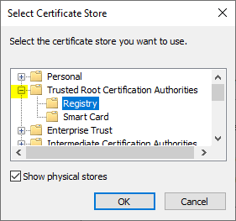
- Click “Next” to install the certificate in the noted Certificate Store.
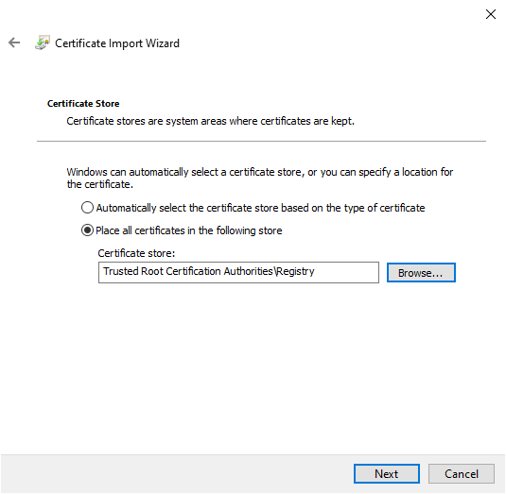
- The Install Wizard should report that the certificate was installed Successfully.
